Challenge: Secure Digital

# Challenge Description :

**We found a car but we are unable to identify if it's the exact one that we have been searching for. The serial network of the car seems intact so we tapped into it and collected some packets. Can you help us find the VIN of the car that is transmitted repeatedly over the network?**

# Context :

## Review the .sal file provided to you. To analyze it, you'll need to install Logic2 from Saleae (saleae.com). This software allows you to view the file's contents and can be used for hardware debugging of protocols such as UART, USB, COM connections, and other raw protocols if curious.

# Flag :

* **First we need to find out what protocol of communication that MicroSD cards use.**
* **Searching that up will provide us with the answer of a SPI [ Serial peripheral interface ] protocol, Using the Guide on Saleae’s website we can help us filter it out the protocol analyzer for the SPI [ Serial peripheral interface ].**
* **We will need this as its SPI uses four channels of communication, Two data signals, one clock signal and an enable signal, this is just based on the most used configuration.**

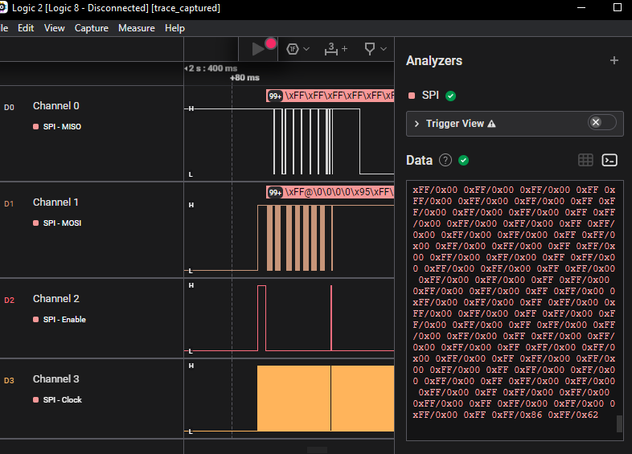

* **Exporting the [ Serial peripheral interface ] SPI analyzer results into a CSV export will give us the flag. Going through the data you will need to spot it out or filter it.**
* **I just opened it with Vscode and CTRL + F, for the “H” character and scrolled till i found it and i did.**

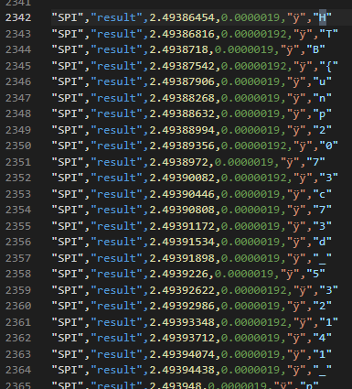

* **The Flag hidden between the lines is**

**: HTB{unp2073c73d_532141_p2070c015_0n_53cu23_d3v1c35}**